Assignment 3

Week beginning 10/02/25

Q1. Draw me a decision tree to classify these labelled data sets A, B and C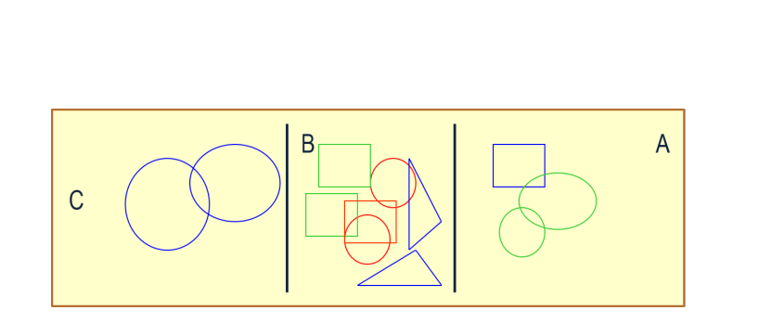

Q2. Are there any problems with using a decision tree algorithm.

Q3. Identify a use of AI in a different industry, for example MYCIN blood infection system in medicine. Are there any ethical considerations for this specific use case?

Q4. Is there a better algorithm to use for classifying the data as in question 1?